Title:
How to Manage Pain and Discomfort While Living With Uterine Fibroids
Keywords:
uterine fibroids, fibroid symptoms, fibroid pain relief, heavy menstrual bleeding, fibroid treatment options, women’s health, pelvic pain
Short Description:
Uterine fibroids are common and can cause heavy bleeding, pain, and discomfort that affect daily life. This article explains what fibroids are, the symptoms to look out for, and practical ways to manage pain and live more comfortably.

How to Manage Pain and Discomfort While Living with Uterine Fibroids
Imagine dealing with heavy periods, constant cramps, or that dragging pain in your lower belly and being told it’s “just part of being a woman.”
For many women, these are actually signs of fibroids. They’re one of the most common health issues affecting women of reproductive age, yet many people don’t even realize they have them.
In fact, research shows that up to 80% of Black women and 70% of White women will develop fibroids by age 50.
The good news is, while fibroids can be uncomfortable and disruptive, there are practical ways to manage the pain and live well, whether through lifestyle changes, simple home remedies, or medical treatments when needed.
What Are Uterine Fibroids?
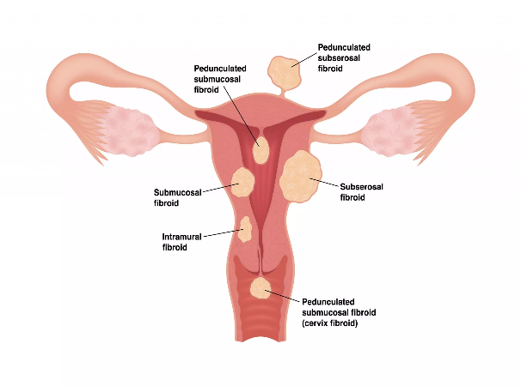
Fibroids are non-cancerous growths that develop in or around the uterus. They can be as small as a seed or grow large enough to press on other organs. Some women may have just one fibroid, while others can have many.
Fibroids are classified based on where they grow:
- Intramural fibroids: grow within the muscle wall of the uterus (the most common type).
- Submucosal fibroids: grow just beneath the inner lining of the uterus and are often associated with heavy bleeding.
- Subserosal fibroids: grow on the outer wall of the uterus and may press on nearby organs.
- Pedunculated fibroids: grow on a stalk inside or outside the uterus
Key facts about fibroids:
a. Most common during the reproductive years (20s–40s).
b. Linked to female hormones (estrogen and progesterone).
c. Often shrink after menopause when hormone levels drop.
d. Risk is higher if you:
- Have a family history of fibroids
- Started menstruating early
- Are overweight or obese
Although fibroids are not cancerous, their size and location can cause different symptoms, from heavy bleeding to pelvic pressure.
Common Symptoms of Fibroids
Some women may experience no symptoms, while others do. But when they do appear, they can affect daily life in different ways. The most common include:
- Heavy or prolonged menstrual bleeding (sometimes with blood clots)
- Severe cramps during periods
- Pelvic pain or pressure (a constant heaviness or dragging feeling in the lower belly)
- Frequent urination or difficulty emptying the bladder
- Backache or leg pain (if fibroids press on nerves)
- Pain during sex
- Bloating or visible swelling of the lower abdomen
- Anemia (weakness and tiredness) due to heavy blood loss
Some women may not have any symptoms at all, which is why fibroids are sometimes only discovered during routine medical check-ups.
Managing Pain and Discomfort from Fibroids
Living with fibroids can be frustrating, but there are ways to ease the pain and discomfort.
The right approach depends on your symptoms, but here are some options that can help:
1. Medications for Pain and Heavy Bleeding
- Over-the-counter pain relievers like ibuprofen or naproxen can reduce menstrual cramps and pelvic pain. These medicines work best when taken at the start of your period.
- Hormonal birth control (pills, injections, or IUDs) may help regulate periods and reduce heavy bleeding.
- Tranexamic acid is a non-hormonal medicine that reduces heavy menstrual bleeding.
- GnRH agonists (e.g., leuprolide) shrink fibroids temporarily by lowering estrogen and progesterone levels. They are usually used for short-term relief or before surgery.
2. Home & Lifestyle Remedies
- Heat therapy: Using a heating pad or warm water bottle on your lower abdomen can relax muscles and reduce cramps.
- Regular exercise: Activities like brisk walking, swimming, or yoga can improve blood flow, reduce pelvic pain, and boost mood. Exercise also helps manage weight, which is linked to fibroid growth.
- Dietary choices: Eat more fruits, vegetables, and whole grains. Studies suggest that diets high in red meat and low in green vegetables may increase the risk of fibroids. Include iron-rich foods (such as spinach, beans, liver, and fortified cereals) if you have heavy bleeding to prevent anemia.
- Stress management: Chronic stress may worsen pain perception. Practices like deep
breathing, prayer, journaling, or mindfulness can help.
3. Medical Procedures (When Symptoms Are Severe)
If medication and lifestyle changes don’t bring enough relief, your doctor may suggest procedures:
- Uterine artery embolization (UAE): A minimally invasive procedure that blocks blood flow to fibroids, causing them to shrink.
- Myomectomy: Surgical removal of fibroids while preserving the uterus is ideal for women who want to keep their fertility.
- Endometrial ablation: Removes the lining of the uterus to reduce bleeding (not suitable if pregnancy is desired).
- Hysterectomy: Complete removal of the uterus is considered the only permanent cure, but it is usually a last resort.
Conclusion
Fibroids can be tough to deal with, but remember, they don’t define you. Many women are living full lives while managing the symptoms in their own way.
Sometimes, hearing how someone else is coping can make things a little easier to bear. If you’ve had your own experience with fibroids, whether it’s the pain, the heavy periods, or even a treatment that worked for you, don’t keep it to yourself.
Share it in the comment section below; your story could be the encouragement another woman needs to take that next step for her health.

Researched by Victoria Odueso

